**Lab 5**

***(Show input and output side by side for all problems****)*

1. Apply Fourier transform to transform an image from spatial domain to frequency domain. Apply inverse Fourier transform to transform the image from frequency domain to spatial domain.
2. Compress the image using Fourier Transform.
3. Apply discrete cosine transform to transform an image from spatial domain to frequency domain. Apply inverse discrete cosine transform to transform the image from frequency domain to spatial domain.
4. Compress the image using Discrete Cosine Transform.
5. Compress the image using Haar Transform.

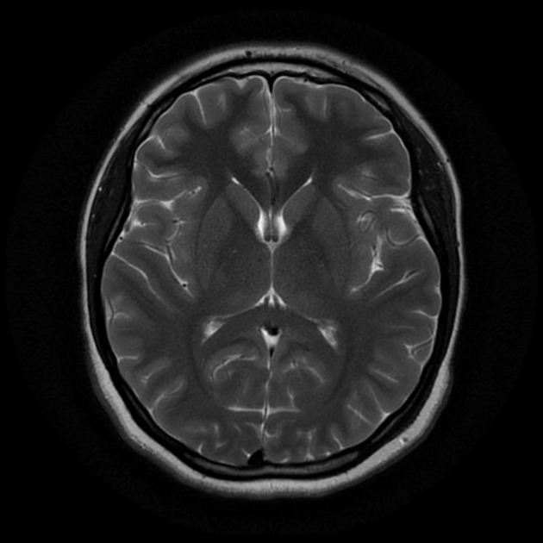

**Figure:** Sample Image